Exercise 9

- List the minimum perks packages.
SELECT MIN(perks) AS minimum_perks FROM employee_data;
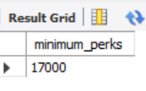
- List the maximum salary given to a “Programmer”.
SELECT MAX(salary) AS max_programmer_salary FROM employee_data WHERE title = 'Programmer';
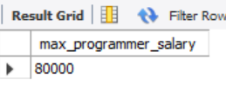
- Display the age of the oldest “Marketing Executive”.
SELECT MAX(age) AS oldest_marketing_exec FROM employee_data WHERE title = 'Marketing Executive';
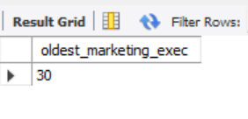
- (Tricky!) Find the first and the last names of the oldest employee.
SELECT f_name, l_name FROM employee_data WHERE age = (SELECT MAX(age) FROM employee_data);
